STEP-WISE PROCEDURE

Step 1: Open the Existing Power BI Report
- Open Microsoft Power BI Desktop.
- Open the Power BI report created in Experiment 4 (EXP 4 BI.pbix).
- Verify that the dataset and required tables are available in the report.
- Check the relationships between Fact_Sales, Dim_Customer, Dim_Product, Dim_Region, and Dim_Date.
- Verify that the existing report pages, including Slice and Dice and Drill, are available.
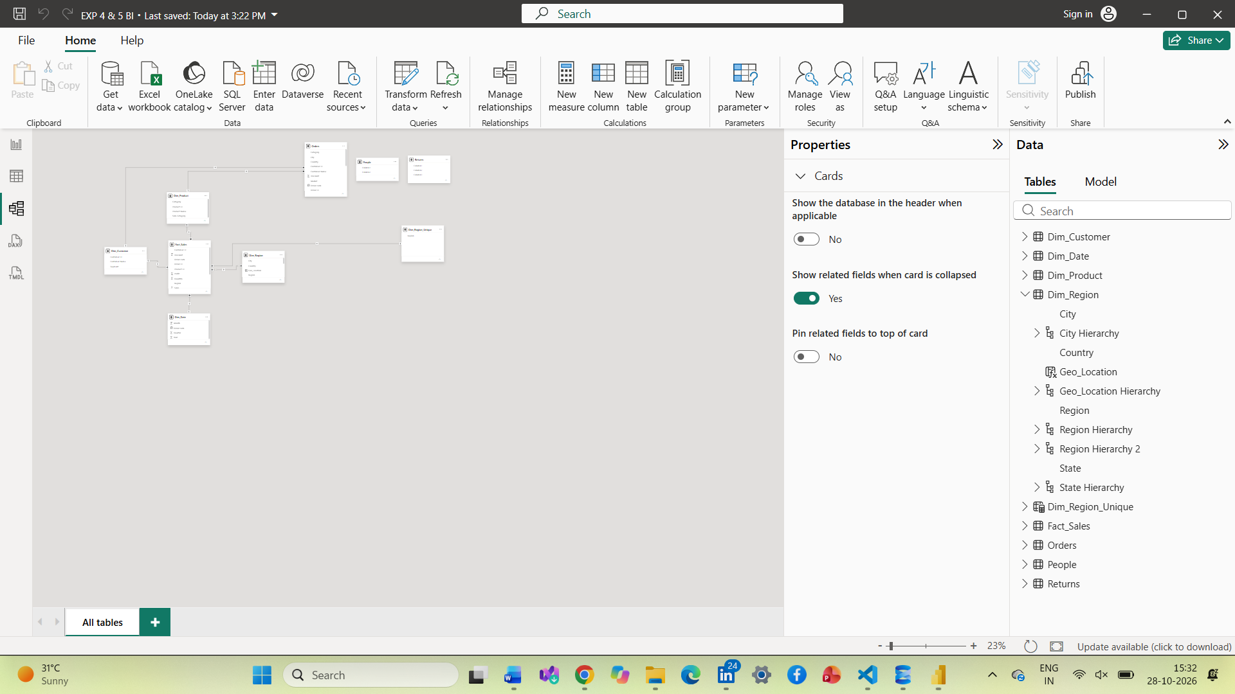
Step 2: Verify the Geo_Hierarchy
- Open the Data or Model view in Power BI.
- Locate the geographical fields Region, State, and City.
- Create or verify the hierarchy named Geo_Hierarchy.
- Arrange the hierarchy levels in the following order: Region, State, and City.
- Verify that the hierarchy can be used to navigate from regional data to state-level and city-level details.
Step 3: Create the Relational Report Page
- Create a new report page and rename it Relational Report.
- Add a Table visual to the report canvas.
- Add the following fields in the specified order:
  - Order ID from Fact_Sales
  - Customer Name from Dim_Customer
  - Product Name from Dim_Product
  - Region from Dim_Region
  - Sales from Fact_Sales
  - Profit from Fact_Sales
- Sort the Sales column in descending order.
- Apply a visual-level filter to display records where Profit is greater than zero.
- Review the displayed sales transactions and identify the highest-sales records.
- If required, export the table data for further examination.
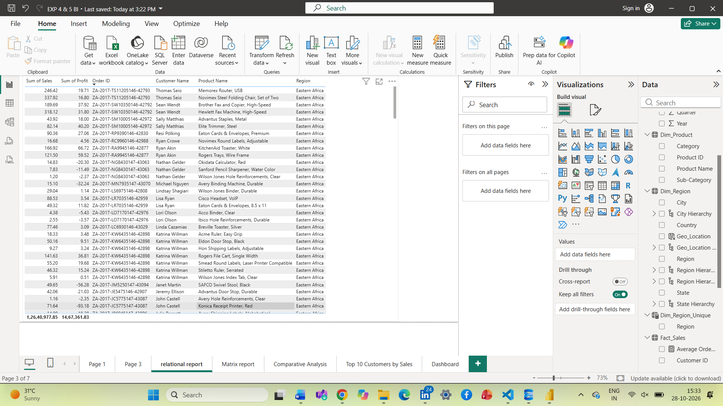

Step 4: Create the Matrix Report Page
- Add a new report page and rename it Matrix Report.
- Insert a Matrix visual.
- Add Geo_Hierarchy to the Rows field.
- Add Total Sales, Total Profit, and Quantity to the Values field.
- Expand the hierarchy from Region to State and then City.
- Examine the sales, profit, and quantity values at different geographical levels.
- Compare the city-level information with the results displayed on the existing Drill page.
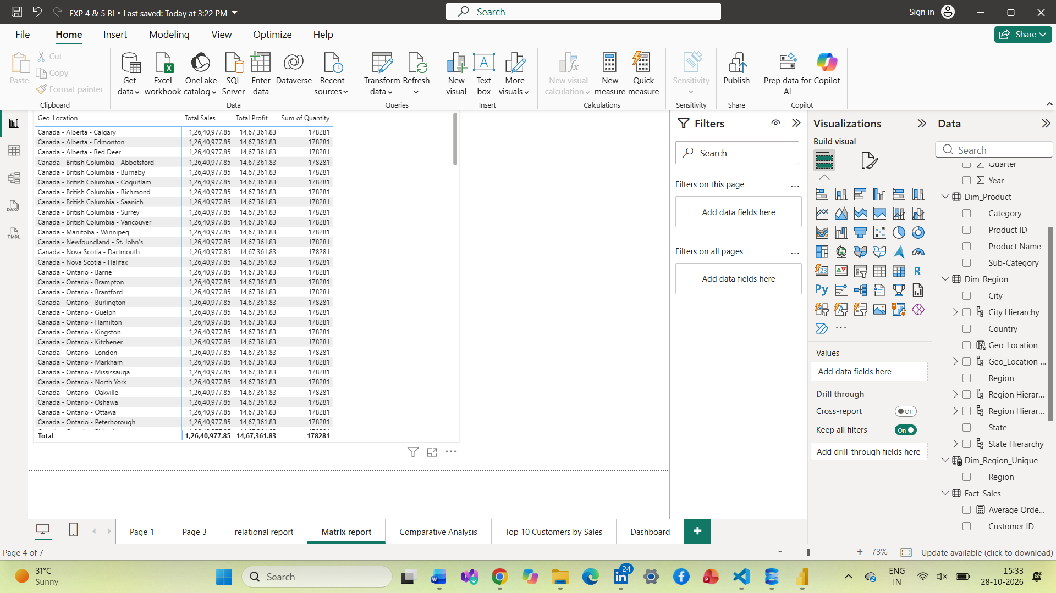
Step 5: Create the Comparative Analysis Page
- Add a new page and rename it Comparative Analysis.
- Create a chart to compare Sales by Category.
- Create a chart to compare Profit by Region.
- Create a chart for Top 10 Customers by Sales. Apply a Top N filter with N set to 10 and use Total Sales as the ranking measure.
- Create a Sales Trend by Year chart using Year from Dim_Date on the X-axis and Total Sales on the Y-axis.
- Arrange the charts neatly on the page.
- Review the differences in sales, profit, customer performance, and yearly sales trends.
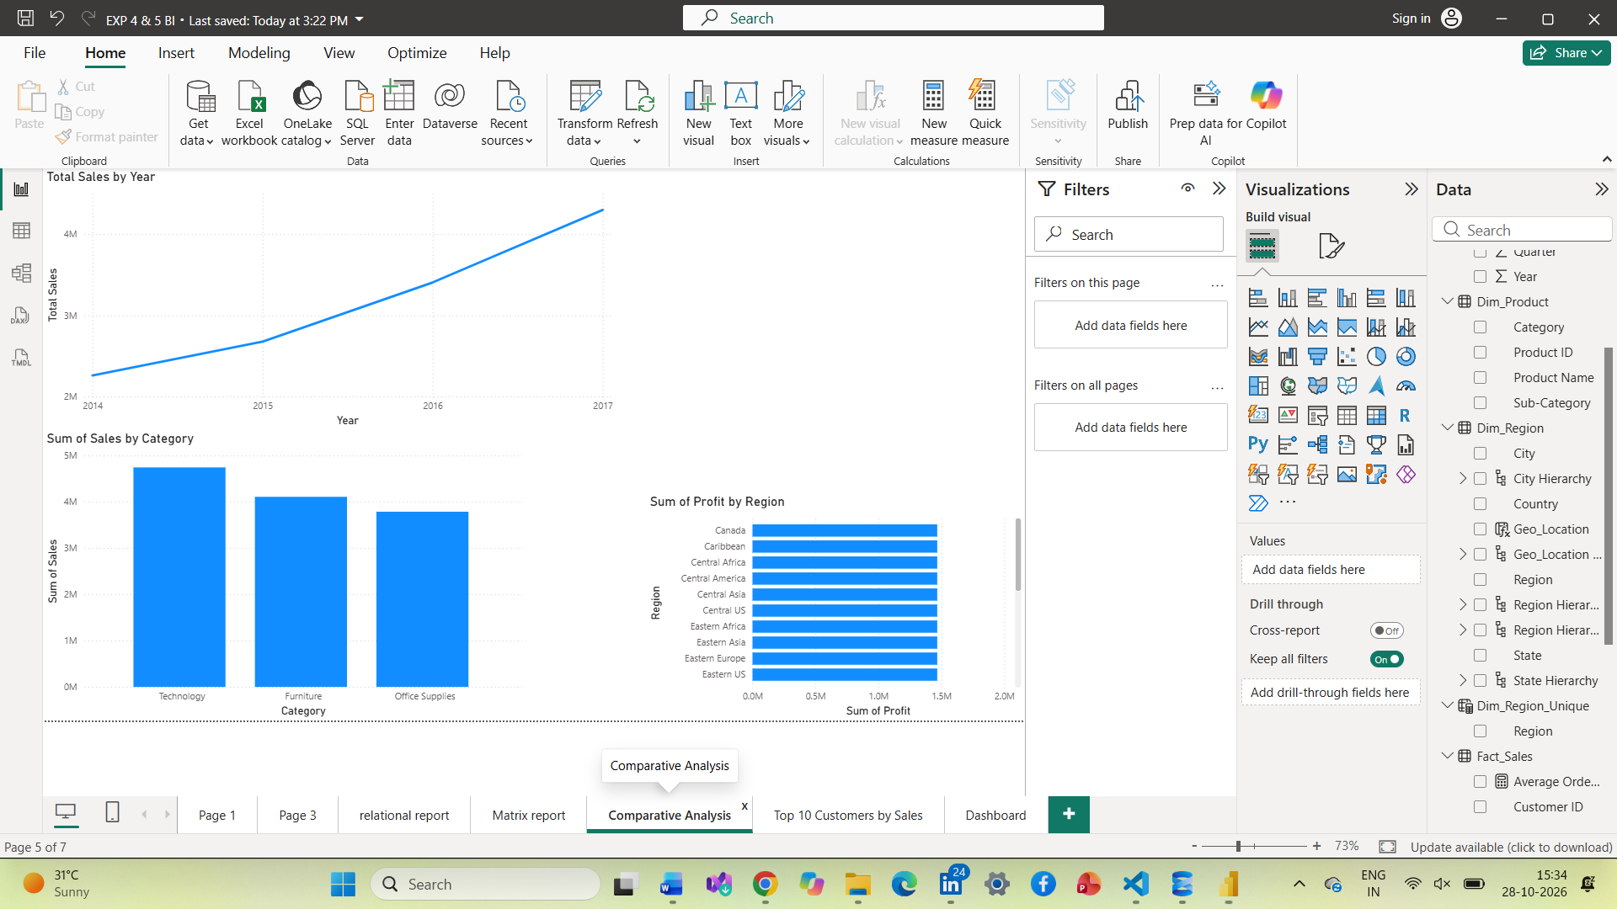
Step 6: Create the Interactive Dashboard Page
- Add a new page and rename it Dashboard.
- Add a Card visual for Total Sales.
- Add a Card visual for Total Profit.
- Add a Card visual for Total Orders.
- Add a Card visual for Quantity.
- Add slicers for Region, Category, and Year.
- Add a chart showing Sales by Category.
- Add a chart showing Profit by Region.
- Add a chart showing the Sales Trend by Year.
- Arrange the cards, slicers, and charts to create a clear dashboard layout.
- Test the slicers by selecting different regions, categories, and years.
- Verify that the relevant visuals respond to the selected filters.
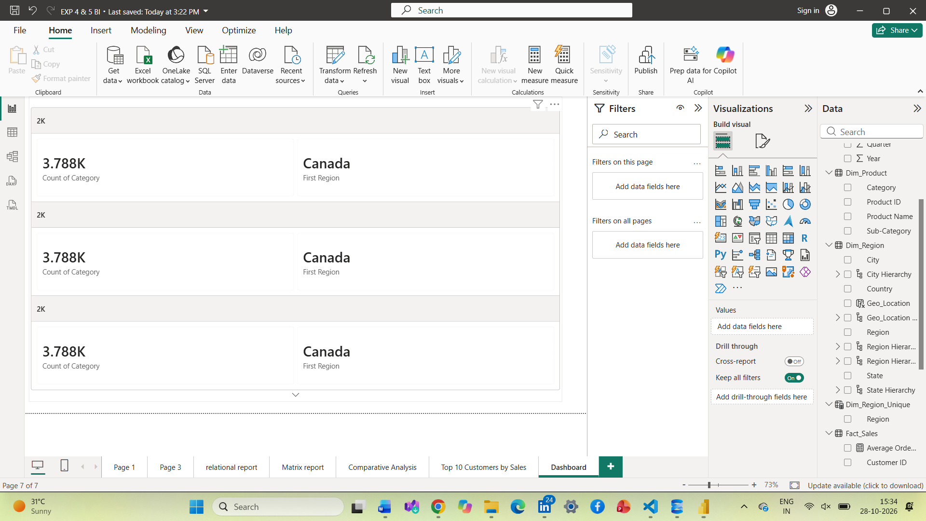
Step 7: Prepare the Summary and Interpretation
- Create a summary table containing the important observations from the Relational Report, Matrix Report, Comparative Analysis, and Dashboard.
- Record the actual observations obtained from the report, such as the highest-sales records, geographical sales patterns, category comparisons, and yearly trends.
- Compare the Dashboard with the Relational Report. The Relational Report displays transaction-level details, while the Dashboard presents aggregated indicators and interactive visual summaries.
- Answer the practical questions using the values and observations displayed in Power BI.
Step 8: Save the Power BI Report
- Review all created pages and verify that the visuals display correctly.
- Check the relationships and geographical hierarchy.
- Test the dashboard slicers one final time.
- Save the report using File → Save.
- Keep the final .pbix file together with the experiment documentation and screenshots.
RESULT
The Relational Report, Matrix Report, Comparative Analysis, and Interactive Dashboard pages were prepared in Power BI to analyze sales data using relational and multidimensional views based on the star schema.

